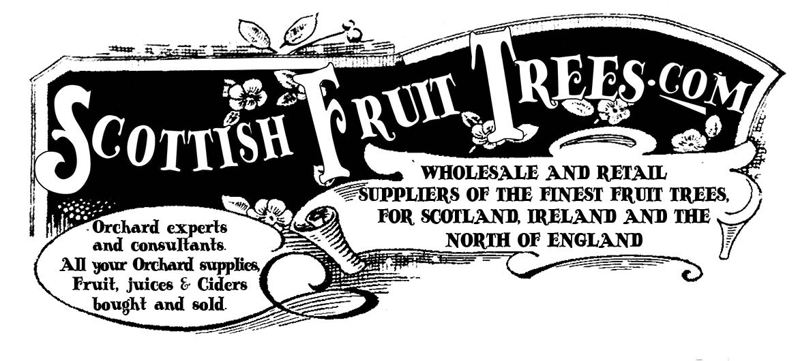

Scottish Fruit Trees

www.scottishfruittrees.com

john@scottishfruittrees.com

2019 - 2020

ORDER FORM

How to use – Fill in your requirements at email to john@scottishfruittrees.com or ring…

John Hancox The Apple Man 0778 606 3918

Stock list (At August 2019) Note stock levels change during the season: Order early
Other fine heritage eating apple varieties recommended for taste and reliability in Scotland
Scottish Apple: | available | Quantity required
Alderman | Yes
Allington Pippin | Yes
Ard Cairn Russet | Yes
Bakers Delicious | Yes
Belle de Boskoop | Yes
Beauty of Moray (dual) | Yes
Bardsey Apple (new for 2019) | Yes
Bloody Ploughman | Yes
Cambusnethan Pippin | Yes
Carlisle Codlin | Yes
Cats Head | Yes
Christmas Pippin | Yes
Clydeside | Yes
Coul Blush (Eater) | Yes
Court Pendu Plat (Roman origin) | Yes
Cox Pomona | Yes
Cutler Grieve (New for 2019) | Yes
Devonshire Quarrenden  (Known in Ireland as “Blood of the Boyne) | Yes
Early Julyan/ Tam Montgomery Eater | Yes
East Lothian Pippin | Yes
Emneth Early, Early Victoria | Yes
Galloway Pippin | Yes
George Cave | Yes
Golden Monday | Yes
Golden Pippin | Yes
Golden Spire (new in 2019) | Yes
Greenup’s Pippin | Yes
Hawthornden | Yes
Hoods Supreme | Yes
Irish Peach | Yes
Kerry Pippin | Yes
James Grieve (fine eater) | Yes
Keswick Codlin | Yes
Lady Sudeley – Early Eater | Yes
Lass O’ Gowrie | Yes
Lemon Queen | Yes
Liberty (New York 1978) | Yes
Lord Roseberry | Yes
Love Beauty | Yes
Lough Key Crab | Yes
Maggie Sinclair | Yes
Mere de Menage | Yes
Miller’s seedling | Yes
Midlothian Blush | yes
Oslin (Arbroath Pippin) | Yes
Orleans Reinette | Yes
Peasgood Nonsuch | Yes
Ribston Pippin | Yes
Sam Young | Yes
Saturn | Yes
Scotch Bridget | Yes
Scotch Dumpling | no
Seaton House | Yes
Scrog | Yes
Slack-ma-Girdle | Yes
Stark’s Earliest | Yes
Stirling Castle | Yes
Stobo Castle | Yes
Tam Montgomery (syn Early Julyan) | Yes
Thorle Pippin | Yes
Tower of Glamis | Yes
White Melrose | Yes
White Paradise | No
White Joaneting (very Early - ready from mid July) | Yes
Widow’s Friend | Yes
Yorkshire Aromatic | Yes

Apple Eating: | available | Quantity Required
Ashmead’s Kernal | Yes
Ellison’s Orange | Yes
Charles Ross | Yes
Discovery | Yes
Egremont Russet | Yes
Fiesta | Yes
Katy | Yes
Laxton’s Fortune | Yes
Red Devil | Yes
Red Falstaff | Yes
Sunset | Yes
Worcester Pearmain | Yes

Classic Apple Cooking: | Available | Quantity required
Howgate Wonder | Yes
Arthur Turner – | Yes
Lord Derby – | Yes
Bramley’s Seedling –. | Yes
Grenadier | Yes

Pears Traditional Scottish | available | Quantity required
Auchan | Yes
Grey Benvie | Yes
Chalk/ Crawford | Yes
Craig | Yes
Cuisse Madame | Yes
Drummond /Charnock | Yes
Flower of Monorgan | Yes
Gouden Knapp / Golden Knap | Yes
Gourdie Hill | Yes
Grey Honey | No
Green Pear of Yare | Yes
Hessle | Yes
Jargonelle | Yes
Longueville | Yes
Lindores | No
Maggie | Yes
Maggie Duncan | Yes
Seggie Den | Yes
Seckle | Yes
White Christie | Yes
Heritage Pears: | available | Quantity required
Conference | Yes
Beth | Yes
Doyenne du Comice | Yes
Williams | Yes
Invincible | Yes

Finest Plum: | Quantity required
Victoria
Marjories Seedling
Opal
Czar
Rivers Early Plum/ Damson (fantastic taste!)
Gordon Castle - Moray North East Scotland
Plum Denbigh – Welsh – good hardy variety

Delicious Damsons: | Quantity required

Merryweather
Shropshire Prune
Farleigh
Longforgan Scottish Damson.

Cherries on top | Quantity required
Cherry Morello
Cherry Lapin (cherokee)
Cherry Colney
Cherry Cariad

Please note we can supply various nut trees, and a wide variety of soft fruit as well. Please ring to discuss your requirements for soft fruit. John – 0778 606 3918

Get thee a nuttery | Quantity
Filbert Kentish Cob
Cobnut Webb's Prize Cob
Filbert Pearson's Prolific / Nottingham Early
Filbert Purpurea / Purple filbert
Filbert Rote Zellernuss / Red filbert
Walnut Broadview (cost £55)
Walnut Buccaneer (cost £55)
Mulberry Wellington (cost £35)

Finest Soft Fruit | Quantity required | Note - prices vary – please contact me to price your soft fruit order
Strawberry Albion, everbearer
Strawberry Sonata
Raspberry Autumn Bliss
Raspberry Glen ample x1
Raspberry Glen Lyon
Raspberry Glen Prosen
Raspberry Malling Jewel
Raspberry Polka
Blackcurrant Ben Alder x 1
Blackcurrant Ben Connan
Redcurrant J. van Tets x 1
Whitecurrant White Versaille
Jostaberry
Gooseberry Captivator
Gooseberry Hinnonmaki Red
Gooseberry Invicta x 1
Thorned blackberry P9
Blackberry Loch Tay
Blackberry Thornfree
Blackberry Waldo
tayberry medana
Blueberry Bluecrop 2L
Blueberry Brigitta Blue 2L
Blueberry Duke
Blueberry Goldtraube
Cranberry 2L
Lingonberry, Vaccinium vitis-idaea Red Pearl P9
Prunus spinosa, Sloe, Blackthorn

Sundries | Quantity required
Stakes ties and accessories (we recommend that you stake trees)
Stakes and ties (£2.50)
“Victorian” label (£2.50)
Mulch sheets (£1)
Rabbit guards (£1.30)

Note – We can also provide training, consultancy, and advice on fruit growing. We also can provide a service to prune, plant and maintain orchards. We do a lot of talks, events and apple days and fruit festivals which are an enjoyable and popular community activity.

Customer Order Form Our Order REF

Your Name:

Please deliver to
Address
Postcode

Email address
Special instructions to courier (ie leave behind greenhouse.)

Telephone number (helpful to discuss any issues with order)

Mobile

Total Quantity of Trees required

Post and Packing - £15 (for up to 8 trees) (please discuss delivery for larger quantities)
Please contact us if remote postcode is likely to apply. If you are having stakes included – this may raise carriage costs. Please discuss.

Please indicate if substitutions for similar trees will be ok if sold out.

Quantity Stakes and Ties at £2.50 per tree
Quantity - Victorian Labels - £2.50 per tree
(mulch sheets and rabbit guards may also available)

SPECIAL SCOTTISH ORCHARD OFFER – Our Selection of Eight tree orchard, (includes P&P ) £159

Cider Apple Trees – 8 apple trees – selected of Scottish cider making - £159

MIXED ORCHARD OFFER – 4 apples and mix of 16 soft fruit plants/bushes £159

Total order value =

Please send the order and payment prior to dispatch of goods.
Cheques payable to “The Children’s Orchard” to The Children’s Orchard.
2 Kelvinside Terrace West, Glasgow G20 6DA.

If you email this completed form we will generate an invoice on request with details for a bank transfer.

If in doubt - Contact John Hancox 0778 606 3918

