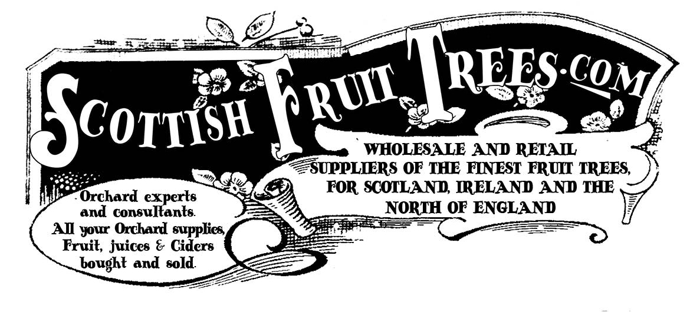

Scottish Fruit Trees

www.scottishfruittrees.com

applejohn@icloud.com

John Hancox

The Apple Man

0778 606 3918

Enquiry Form

Your name

Your address – including the postcode.

Your phone number – so I can ring you to discuss

Proposed orchard location – space available, soil conditions etc, is it sunny and open. Prone to flooding or being wet ?

Give me some information also about how you intend to manage the orchard/ fruit trees – who will do it… how much time do you have to maintain them?

What is your aim in terms of using the fruit?

Photos of the site can also be very useful … which you could send along with this enquiry form.

Do you need a site visit? (usually I’d suggest a discussion by phone first)

Thanks – and look forward to help with moving this forward. …
John

